Private Bag X6001, Potchefstroom
South Africa 2520
Tel: (018) 299-1111/2222
Web: http://www.nwu.ac.za
School for Physiology, Nutrition and Consumer Science
Tel: (018) +27 018 299 2085
Fax (018) +27 018 299 2464
EMail Hattie.Wright@nwu.ac.za@nwu.ac.za
20 December 2009
Prof D Labadarios
Editor-in-Chief
SAJCN
Dear Prof Labadarios
DECLARATION OF CONTRIBUTION TO MANUSCRIPT:
Dietary ASSESSMENT methodology for adolescents: a review of reproducibility and validation studies
¹ Rankin D, ¹Hanekom SM, ¹Wright HH, ²MacIntyre UE,

This letter confirms our contribution to the attached paper. This is an original review article on the topic mentioned above. We have participated sufficiently in the writing of this article to take public responsibility for it. We have reviewed the final version of the article and approve it for submission for possible publication.

Kind regards

Yours sincerely
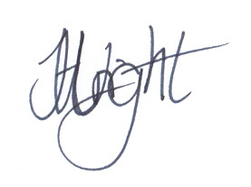
Dr HH Wright RD(SA)
Senior lecturer

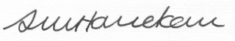
Dr SM Hanekom
Senior Lecturer

